Students between 6-16 years old must be enrolled at school. Once enrolled, it is compulsory to attend regularly, unless a specific exemption has been approved by the school and the Ministry of Education. (Education and Training Act 2020, s 35).

Parent/Guardian and student responsibilities

Parents and guardians have legal obligations to ensure their children attend school (Education and Training Act, s 244). We expect parents/guardians to:

- notify the school as soon as possible if their child is going to be late or absent for any reason
- arrange appointments and trips outside school hours or during school holidays where possible

Leaving school grounds

Students are not allowed to leave the school during school hours unless permission is requested by parents/caregivers and given by the school. The student must sign out at the student office. They must have a note signed by their teacher, or their parents/caregivers must have notified the student office. Attendance at Villa Maria College is entered every period into our Student Management System (SMS). Ako teachers, Heads of House, and the Deputy Principal monitor all attendance. An automated text and email are sent to parents to inform them of unexplained absences where a parent has not notified us that their child will be away.

Sickness

The procedure for students who become ill during the day is to first approach the teacher (if in class) OR come directly to the Student Office to request first aid from staff, who will then make contact home to parents/caregivers as necessary. It is requested students not contact home directly. This is for the safety of your daughter while in the care of the College.

If a student is going to be away for more than three days, parents need to notify the principal. We record attendance accurately and ensure the information is available in emergencies to ensure all students are accounted for. We monitor absence patterns using our student management system, and parents/caregivers are notified of any concerns.

Justified absence

If there’s a justified reason for absence (eg. illness, a funeral or tangihanga, or other approved reason at the discretion of the school), the principal may allow a student to be absent for up to five days (Education and Training Act 2020, s 45).

Planned absence

In the case of planned absences, (including overseas holidays) requests must be made to the principal at least one week before the planned event. The principal has the discretion to approve or deny requests, based on criteria including:
- the benefit to education for the student (including qualifications and experience of course providers as relevant)
- the length of time away from regular school programmes that the activity will require.
- It is not up to the school/staff to provide lessons or homework to make up for classes missed in these instances.

How to notify the College of an absence

If your child cannot attend school, please inform the school as early as possible via:

- College App (Search your App Store for ‘SchoolAppsNZ’, download, and set Villa Maria College as your default school.) Please include a clear reason for the absence.
- Phone the college on 348 4165 (following the voice instructions to record the absence, including your daughter’s name and Ako).

How absence is classified

- If a sickness absence is for a period longer than three days, a medical certificate may be required. If the sickness absence is for a period longer than five days a medical certificate will be required.
- If an absence is due to overseas travel or a family holiday, it will be coded G, which will appear as unjustified.
- Students with more than five days of unexplained absence will be contacted by the school for an explanation or invited for a whānau meeting if attendance becomes a concern.
- Being on time for school also represents missed learning opportunities. We encourage our students to be on time, as this is an excellent habit to reinforce for the world of work.

Why does attendance matter?

Being at school everyday matters. There are four attendance categories:

- Regular attendance: Students with over 90% attendance, missing fewer than five days of school in a standard ten-week term
- Irregular absence: Students with more than 80% and up to 90% attendance
- Moderate absence: Students with more than 70% and up to 80% attendance
- Chronic absence: Students with 70% attendance or less

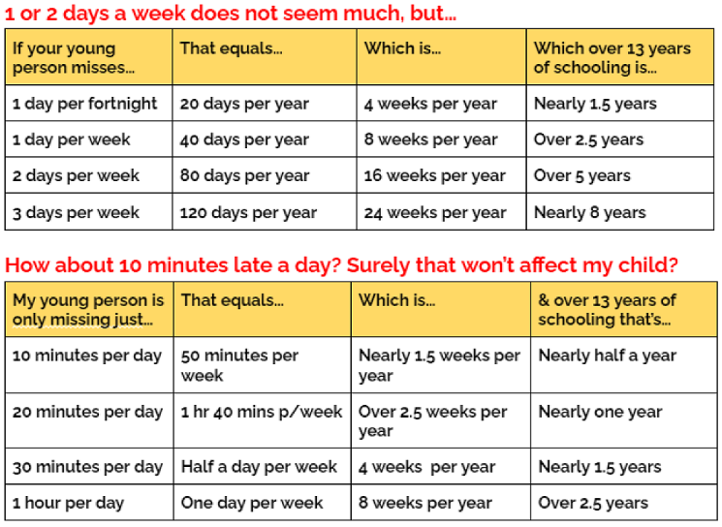

Ministry of Education explanation tables

Justified Absence:

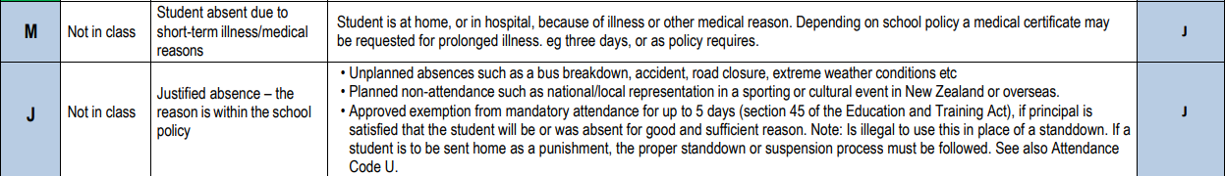

Unjustified Absence:
